4th meeting of the Waterborne Technical Committee
Multimodality in practice – challenges in the Western Balkans Region and the Belgian solution

Mercure Hotel City Centre Antwerp, Belgium, and MS TEAMS
14th – 16th December 2022
CONCLUSIONS

14 December 2022
- The agenda of the meeting was adopted and a point on EU (European Union) environment acquis and policy developments by DG ENV was added.
- The Technical Committees are welcomed by Transport Community Permanent Secretariat’s Director Matej Zakonjšek who thanked Belgian hosts for accepting to organize the event in Antwerp, and for sharing their expertise and offering a lesson on multimodality in one of Europe’s most important ports. It should help regional partners to understand more about the solutions put in place to ensure coherence between the land specific rules, inland and maritime navigation.
- Mr. Mohssine El Kahloun welcomed the delegations of the regional partners on behalf of the Belgian delegation and recognised that difficulties in coordination are encountered in all administrations.
- The representatives of DG MOVE also welcomed the regional participants to Belgium.
- A brief overview concerning the activities of the TCT Permanent Secretariat, followed. It highlighted the main findings of the Progress reports for these Committees and the evolution of the Regional Partners’ policies.
- Mr. Mircea Ionescu, Seconded National Expert, Unit C.2 Road Safety, DG MOVE presented multimodal aspects in transport of dangerous goods from the EC’s Sustainable and Smart Mobility Strategy. Milestones by 2030 and 2050 as well as the flagships related to greening, and multimodality were presented. It was reiterated that consolidated text of Directive 95/50/EC with all the amendments has been published under new number- Directive 2022/1999 and it will enter into force as of 1 January 2023.
- The TCTDG welcomed the presentation on eFTI implementation & latest developments given by Mr. Villu Varjas, Policy Assistant, Unit D.1 Maritime Transport and Logistics, DG MOVE. He presented the indicative timeline for implementation and application of the eFTI Regulation and the ongoing work on definition of data set and data subsets for the eFTI data model. It was explained that the ongoing works are based on the UN/CEFACT Multimodal Transport Reference Data Model and there is ongoing work to align definitions and formats with the Union’s Customs Code and European Maritime Single Window data model, the model endorsed by UNECE for transport of dangerous goods and the EU Shipping Generated Waste Regulation.
- EU environment acquis and policy developments for emissions of air pollutants affecting shipping and ports were presented by Mr. Wilhelmus De Wilt, Policy Officer Clean Air & Urban Policy (ENV.C.3). In his intervention he invited all representatives of the Regional Partners to make sure that intramodality is integrated and linked to the Sustainable Urban Mobility Plans, Air Quality and Noise Plans, as well as Energy and Climate Plans. All experts were kindly invited to look for synergies and to build up interdisciplinary teams in administrations in order to avoid silo thinking. Moreover, the data already available – e.g., EU projects: LIFE, Horizon, REGIO (incl. Interreg), CEF, InvestEU etc. should be screened to find sources of inspiration towards greening policies. Cross-border cooperation will facilitate EU funding and Regional Partners were encouraged to enhance cooperation with EU Member States on transport and environmental issues. The Commission and the EU Agencies can facilitate this work if necessary.
- Mr. Nico Suys from the Antwerp/Flanders Port Training Centre (APEC) Briefly presented the history of the Port of Antwerp. Recently one common port authority was created to cater for two historical inland waterways ports - Antwerp and Bruges. The decision was taken recently to manage port affairs and develop in a harmonized manner navigation in the Antwerp Bruges area more effectively. The efforts of the Port authority to be more open to the local community and economic actors involved were also highlighted. The Port’s structure was briefly presented, as well as the brief agenda of the visit to port envisaged for all present representatives of Regional Partners on 15 December.
14 December 2022 afternoon session.
- Mr. Elson Thana welcomed the participants from RPs, EMSA, DG MOVE, IMO and invited the representative of RPs to present the activities on maritime and IWW of the Regional Partners.
- The representatives of Albania stated that there had been incremental implementation of the roadmap for the improving of the performance of the Albanian flagged fleet that involved the implementation of several EU regulations. Out of 34 measures contained in the Roadmap, 15 had been completed, 3 were ongoing, and 6 had not started yet. A TAIEX was conducted in a one-week workshop in Durres. Albania was assisted by EMSA within the context of the IPA II project financed by DG NEAR. The assistance consisted amongst others in the
  - donation of AIS base stations and node to facilitate the participation of Albania in the sharing of AIS information with regional partners and the EU MSs,
  - support to draft the maritime strategy according III Code,
  - support to develop a QMS based on ISO 9001 standards for the maritime administration that is supposed to certified by March 2023,
  - through external experts’ audit of the Albanian Register of Shipping and five training institutions for seafarers,
  - support to draft the national legislation transposing the EU directives on port reception facilities and marine accidents investigation.
In 2021-2022, the number of Albanian vessels inspection and detention from Albanian authorities (FSC) to Albanian flagged vessels was increased by at least 30%. Unfortunately, there were two detentions in Paris MoU port in December which lower down the possibilities for Albania to get out from the blacklist of Paris MoU on Port State Control. Albania has a small fleet of 13 commercial vessels for international transport. With the technical assistance of EMSA a quality management system of the Maritime Administration is in the process of establishment. The Albanian representative requested assistance from the TCT Permanent Secretariat in this fields:
- Recognition from EU of Seafarers’ Certificates. There is a need that an EU Member State proposes to European Commission the recognition of Albanian seafarers’ certificates. For these reasons Albanian representative requested Permanent Secretariat to start this important process.
- Twinning/TAIEX was requested for training and capacity building of the maritime administration personnel especially the Flag State and Port State Control and STCW.
- Transposition of certain EU directives.
- Regarding the Maritime National Single Window, Albania mentioned that there is already operational a system monitored by the Interinstitutional Maritime Operational Centre (IMOC). There is a need for an assessment of the activities in order to check if it fulfils the requirements to be used as MNSW. The same problem also exists with the legislation in force needed to be transposed the latest EU directive. EMSA representative mentioned that this is under the objective of EMSA TA and could be discussed to be covered for the second phase of the TA.
The Albanian representative was advised to officially request the needs for assistance to TCT Permanent Secretariat.
- The representative of Bosnia and Herzegovina presented the geostrategic position and administrative structure of Bosnia and Herzegovina (BiH), maritime transport and inland waterway, and the state of play in terms of the implementation of Annex 1 (1.4 and 1.5) of the TCT. It was stated that Bosnia and Hercegovina have a coastline of 24.5 km (about 15.22 mi) in the Adriatic Sea monitored by the Port Authority Neum, as a part of the Federal Ministry of Transport and Communications (entity level of the Government) and 332.4 km (about 206.54 mi) of the Sava River monitored by the Inland Waterway Port Authorities responsible for the navigation in Brcko District, Republic Srpska and Federation of Bosnia and Herzegovina. It was stated that there is a need for one law on inland waterways and maritime at the state level. Draft law that was prepared in 2014. However, it has never been adopted. The representative stated that adoption of this law should be discussed and agreed at the political level among different authorities in Bosnia and Herzegovina (state and entity level). It would be desirable for such a decision to be supported by the RSC and ministerial level of the TCT. After the “political” approval of the law inside Bosnia and Herzegovina, it could be started with the procedure of preparation of the Draft law and transposing the EU legislation in Annex 1 of the TCT. He also pointed out that the project from the World bank and WBIF (Western Balkans Investment Framework) on demining of the left bank of the Sava River is a priority and that the WBIF decided to grant funds for that as demining is the precondition for the rehabilitation of inland waterway.
- The representative of Kosovo stated that they were in the first phase of creating policy in the field of waterborne and multimodal transport, and that they should take the best practices of the countries in the region and more broadly for the development of maritime and multimodal transport. As Kosovo does not have ports or inland waterways, maritime transport is mentioned only under multimodality in the context of access to three major ports in neighbouring countries which are important for Kosovo’s exports and imports. Investments are needed into rail, road, border, and terminal infrastructure to improve multimodal connections with these ports. In the future, Kosovo will need technical assistance through TAIEX or Twining programs; preparation of the legal basis according to international standards, respectively harmonized with annex 1.4 and 1.5 of the Transport community Treaty; capacity building, specifically on waterborne transport.
- The representative of Montenegro presented a detailed overview of the implementation status of the Action Plan for Waterborne Transport and Multimodality, in particular what regulations were partially transposed, fully transposed and in progress to be fully transposed. In addition to that, EMSA technical assistance and ongoing projects were also presented. With EMSA TA is now drafted the legislation for the implementation of the consolidated edition of MARPOL Convention and the Search and Rescue Plans. Through the Project „Technical Assistance for Capacity Support to the Transport Sector and EU Acquis Alignment in Montenegro”, PWA/MNE/IPA II/CAP17/SER/01-8132/1, a framework contract was signed for the transposition, among the others and of the “Directive 2010/65/EU of the European Parliament and of the Council of 20 October 2010 on reporting formalities for ships arriving in and/or departing from ports of the Member States”. Directive 2010/65 was amended by Directive (EU) 2019/883 of the European Parliament and of the Council of 17 April 2019 on port reception facilities for the delivery of waste from ships, which will be transposed through the act fully. Members of the established Working Group work on it. Through IPA II CAP 2017 is planned implementation of the project for the establishment of the NMSW system (hardware and software). At the end of 2021, tender procedures were completed and contracts for the second phase of VTMIS and NMSW were signed, and implementation is ongoing. The contract for NMSW was signed on 15 December 2021 and for VTMIS II on 13 December 2021 and implementation began in January 2022. Completion of all activities is planned for 2024 when the NMSW is expected to be commissioned.
In parallel with the implementation of the NMSW, it is planned to draft bylaws for the implementation of the NMSW EU legislation into national legislation. Other projects include the development of the ITS strategy and digitalization of the Port of Bar. Support for these activities will be agreed. This system is planned to be established in the first quarter of 2024. Other projects include the development of the ITS strategy and digitalization of the Port of Bar, to be done with the support of the World Bank.
The representative of MNE pointed out that during the last months they had a technical Evaluation of the Paris MoU and from the Fact-Findings mission resulted that MNE has fulfilled all the requirements to be part of the Paris MoU on Port State Control. Government of Montenegro adopted the proposal of the Nairobi Convention on Wreck Removal. The only action needed is the training of the PSC officers according to the Paris MoU training program to be delivered at EMSA premises.
After discussions the MNE representatives requested TCT Permanent Secretariat to coordinate with EMSA and Paris MoU Secretariat to help in completing this task.
The MNE representatives were advised to send the request by email and TCT will contact EMSA and Paris MoU Secretariat in order to coordinate the agencies to complete this important task.
- The representative of North Macedonia presented the current situation on inland waterways navigation in the country and appropriate number of vessels certified for sailing. Navigation is mainly at the national level, with occasional international navigation with Albania. There are two main lakes used for national/international navigation, it is Ohrid Lake used to international navigation with Republic of Albania and Prespa lake used for international navigation with Republic of Albania and Greece. Transportation of goods and dangerous goods in inland waters in North Macedonia is prohibited by law. The certification of the vessels is done by the Recognized Organization (RO) Bureau Veritas. Annual planning was presented for the improvement of inland waterways. The representative stated that multimodal transport was a top priority of our government which was included in the national development strategy.
North Macedonia due to the low number of the seafarers has no training centres for these reasons they require assistance from one Neighbour country either Albania or Serbia in order to assist them with the training of the boat masters. Albania expressed the willingness and the availability for the assistance, while the representative of Serbia will discuss with the responsible Serbian authorities and will reply to the request. The representative of North Macedonia requested from the TCT Permanent Secretariat Technical Assistance on the transposition of the legislation of Annex 1.5.
- The representative of Serbia presented a detailed overview of inland navigation in Serbia and their three priorities: the removal of bottlenecks, port capacity development and application of ICT. By end of 2022, Serbia will file a formal request for the recognition of professional certificates.
- EMSA representative presented the activities completed or going within the context of the EU financed (DG NEAR) project “Preparatory measures for the future participation of relevant IPA II countries in the EMSA”. The project has evolved, and it is now a powerful mean to support the beneficiaries with the transposition of the international and EU maritime legislation into the national legislative system as well as with support in other areas including trainings through the EMSA’s Academy, support to prepare and follow-up the IMSAS audit, preparing implementing procedures, studies on adequacy of port reception facilities and support to develop quality management systems according to ISO 9001. Finally, the beneficiaries are provided with a number of services and tools developed for the EU Member States. The EMSA representative also said that the project, ending on 30 June 2023, will be very likely continued with a new one financed under IPA III.
- Mr. Casto Lopez Benitez from DG MOVE maritime transport delivered a presentation on the latest development of the directive on Port Reception Facilities and the measures for the implementation of the Green Agenda.
- Ms. Inge De Would, from the Port of Antwerp presented the project “PIONEERS” “The challenges of EU Ports under European Green Agenda”. PIONEERS is one of the H2020 Green Deal Call projects addressing the challenges faced by European ports to reduce their environmental impact while remaining competitive and offering added value in a sustainable global trade ecosystem.
The project kicked off in October 2021 with a consortium of 46 partners and aims to deliver a Green Port Master Plan to become climate neutral by 2050 in line with the EU Green Deal targets.
By 2026 a master plan will be drafted that can serve as a guideline for all European ports and covering many different areas of port and terminal operations, intramodality, energy transition, improvement of cargo and passenger flows through digitalisation. Port of Antwerp Bruges is the lighthouse port, and it is working closely with the ports of Barcelona, Constanta, and Venlo, involved as fellow ports in the consortium, and representing the ideal mix of size, location, operation models and area of influence to test these demonstrations, during the project lifecycle. More info on www.pioneers-ports.eu and updates on the project can be obtained by subscribing through our stakeholder community.
- Mr. Dimitri Laureys from the Port of Antwerp presented the H2020 project ePIcenter “Enabling resilient, efficient and greener supply chains”.
ePIcenter is the second H2020 project coordinated by Port of Antwerp. It started in 2021 with 35 partners and aims to enable greener, more resilient, and optimized transport by exploring digitalization, data sharing and new technologies and routes. The project duration is 42 months. ePIcenter aims to accelerate progress towards the Physical Internet concept by working on synchro modal transport, enabled through increased visibility.
The ePIcenter demonstrators are:
- The ePI-link demonstrator, focusing on international connections and new routes and on potential for digitalization and data sharing along those connections to improve operational efficiency.
- The ePI-node demonstrator looks at new technologies and how to integrate them into the existing transport network. Specifically, these technologies are: hyperloop, autonomous electric vehicles and modular containers aimed at providing a solution for the equipment imbalance.
- The Arctic demonstrator, looking at the potential and risks of transport through the arctic region, taking into account navigation, the potential of AI-based propulsion optimization and impact on eco-sensitive areas and wildlife impact.
- Mr. Ivaylo Valev, representing IMO, being the last speaker suggested that in the interest of time his PPT presentation to be disseminated amongst the participants and availed himself to answer any queries related to IMO instruments and explained that relevant procedure should be strictly followed in order to continue the cooperation with IMO through its Integrated Technical Cooperation Programme. He pointed out that beneficiaries need to state specifically what kind of technical assistance they would be seeking from IMO and the related IMO instrument.
In addition and following the reports from the regional partners which were land-locked States Mr. Valev provided some advice on the benefit of becoming a Party to the United Nations Convention on the Law of the Sea (UNCLOS). He drew the attention of participants to Part X of UNCLOS, related to the right of access of land-locked States to and from the sea and freedom of transit, and in particular its Article 125, which stated as follows:
  - Land-locked States shall have the right of access to and from the sea for the purpose of exercising the rights provided for in this Convention including those relating to the freedom of the high seas and the common heritage of mankind. To this end, land-locked States shall enjoy freedom of transit through the territory of transit States by all means of transport.
  - The terms and modalities for exercising freedom of transit shall be agreed between the land-locked States and transit States concerned through bilateral, subregional or regional agreements.
Transit States, in the exercise of their full sovereignty over their territory, shall have the right to take all measures necessary to ensure that the rights and facilities provided for in this Part for land-locked States shall in no way infringe their legitimate interests.
Mr. Valev ably answered several questions from the participants and wished everyone success with the 4th Meeting of the WTC during the week.
16 December 2022
- TCT Secretariat thanked all regional partners for their contributions. Further efforts are needed to meet the measures and deadlines set in Guidelines: Directive 2008/68/EC on the inland transport of dangerous goods and Directive (EU) 2022/1999 on uniform procedures for checks on the transport of dangerous goods by road (codification).
- The representatives of Kosovo thanked TCT for this lesson concerning multimodality and highlighted that the region needs lots of investments in infrastructure.
- The representative of Bosnia and Herzegovina expressed a small disappointment that the visit to Port Antwerp did not cover more the IWW part. He also hoped that the WBIF funding for the demining of the Sava River will be realized soon. Sava is the main IWW in the region and partial use affects the economies of the riparian Regional Partners and EU Member States. The ports of Slavonski Brod, Samac and Brcko are seriously affected due to the standstill on funding for the demining process of the right riverbank of this river Sava. Voluntary demining was performed in a few cases by the industry itself, but this is still not sufficient. Completing the demining process of the right riverbank of the river Sava is the basic precondition for the complete rehabilitation of this IWW, and transformation of these 3 ports into multimodal hubs. TCT Secretariat took all comments onboard and further discussions will follow with all relevant stakeholders in the future. A meeting with Bosnia and Herzegovina will be following in January or February.
- The representatives of Albania listed the areas in which further assistance is needed and expressed hope that based on this experience similar events would be created in order to see in practice the coherence between the different areas of work of the authorities.
- The representative of TCT Permanent Secretariat, Mr. Elson Thana, invited all Regional Partners to consider using IPA funding to develop EU Acquis implementation, on the model of Albania in recent years. TAIEX was also highlighted as an important area for capacity building.
- The representatives of Montenegro also mentioned that a training for port state control officers will be needed.
- The representative of North Macedonia mentioned the problem of recognition of botmasters certificates for IWW and mentioned also that further improvement could be envisaged in terms of professional training of all relevant participants in transport operations.
- The representative of Serbia also offered to help in the demining issues concerning the Sava River and he offered to check the situation with the recognition of the botmaster certificates. It was agreed, as a matter of principle to clarify this issue bilaterally with North Macedonia.
- Regional partners were invited to express their requests for assistance in any TDG related area of work, cooperation, and enforcement.
- TCT Secretariat announced the events planned in 2023 for TDG and Waterborne Committees.

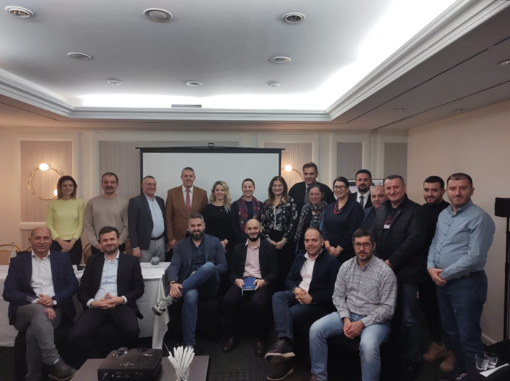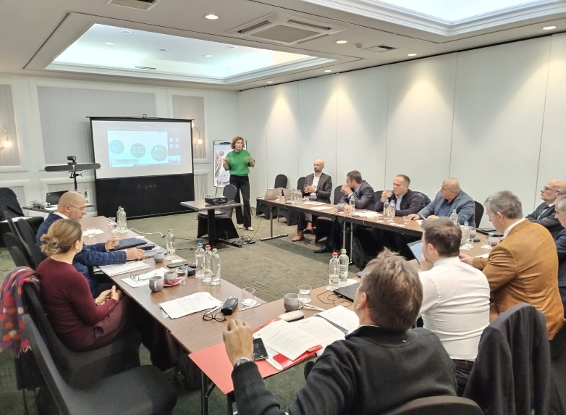

Regulation (EU) 2020/1056 of the European Parliament and of the Council of 15 July 2020 on electronic freight transport information, OJ L 249, 31.7.2020, p. 33.

